WPL LAB 3
name: Abhinav Singh Bhagtana
section: A
roll no: 29
reg no: 230905225

Q1.Design an attractive ‘train ticket booking form’ using different bootstrap elements.
<!DOCTYPE html>
<html lang="en">
<head>
<meta charset="UTF-8">
<meta name="viewport" content="width=device-width, initial-scale=1.0">
<title>Train Ticket Booking</title>
<link href="https://cdn.jsdelivr.net/npm/bootstrap@5.3.0/dist/css/bootstrap.min.css" rel="stylesheet">
<link href="https://cdn.jsdelivr.net/npm/bootstrap-icons@1.10.5/font/bootstrap-icons.css" rel="stylesheet">
<style>
body {
background-color: #eef2f7; /* Soft gray background to make cards pop */
font-family: 'Segoe UI', Roboto, Helvetica, Arial, sans-serif;
}
.main-container {
max-width: 900px;
margin-top: 40px;
margin-bottom: 40px;
}
.booking-card {
border: none;
border-radius: 15px;
box-shadow: 0 10px 30px rgba(0, 0, 0, 0.08);
overflow: hidden;
}
.card-header-custom {
background: linear-gradient(135deg, #0d6efd 0%, #0a58ca 100%);
color: white;
padding: 25px;
text-align: center;
}
.section-title {
color: #0a58ca;
font-weight: 600;
margin-bottom: 20px;
display: flex;
align-items: center;
}
.section-title i {
margin-right: 10px;
font-size: 1.2rem;
}
.form-floating > label {
color: #6c757d;
}
.btn-book {
padding: 12px;
font-size: 1.1rem;
font-weight: bold;
border-radius: 10px;
}
</style>
</head>
<body>

<div class="container main-container">
<div class="card booking-card">
<div class="card-header-custom">
<h2><i class="bi bi-train-front-fill me-3"></i>RapidRail Booking</h2>
<p class="mb-0 opacity-75">Find your next destination</p>
</div>

<div class="card-body p-4 p-md-5">
<form>
<h5 class="section-title"><i class="bi bi-map-fill"></i>Trip Details</h5>

<div class="row g-3 mb-4">
<div class="col-md-6">
<div class="input-group input-group-lg">
<span class="input-group-text bg-light"><i class="bi bi-geo-alt-fill text-primary"></i></span>
<div class="form-floating flex-grow-1">
<input type="text" class="form-control" id="floatingFrom" placeholder="From Station">
<label for="floatingFrom">From Station</label>
</div>
</div>
</div>
<div class="col-md-6">
<div class="input-group input-group-lg">
<span class="input-group-text bg-light"><i class="bi bi-pin-map-fill text-danger"></i></span>
<div class="form-floating flex-grow-1">
<input type="text" class="form-control" id="floatingTo" placeholder="To Station">
<label for="floatingTo">To Station</label>
</div>
</div>
</div>

<div class="col-md-4">
<div class="form-floating">
<input type="date" class="form-control" id="journeyDate">
<label for="journeyDate">Journey Date</label>
</div>
</div>
<div class="col-md-4">
<div class="form-floating">
<select class="form-select" id="travelClass" aria-label="Travel Class">
<option selected>Select Class</option>
<option value="1">AC First Class (1A)</option>
<option value="2">AC 2 Tier (2A)</option>
<option value="3">AC 3 Tier (3A)</option>
<option value="4">Sleeper (SL)</option>
</select>
<label for="travelClass">Class of Travel</label>
</div>
</div>
<div class="col-md-4">
<div class="form-floating">
<select class="form-select" id="passengerCount" aria-label="Number of Passengers">
<option value="1" selected>1 Passenger</option>
<option value="2">2 Passengers</option>
<option value="3">3 Passengers</option>
<option value="4">4 Passengers</option>
</select>
<label for="passengerCount">Travelers</label>
</div>
</div>
</div>

<hr class="my-5 text-muted opacity-25">

<h5 class="section-title"><i class="bi bi-person-vcard-fill"></i>Primary Passenger</h5>

<div class="row g-3 mb-4">
<div class="col-md-6">
<div class="form-floating">
<input type="text" class="form-control" id="fullName" placeholder="Full Name as on ID">
<label for="fullName">Full Name (as on ID)</label>
</div>
</div>
<div class="col-md-3">
<div class="form-floating">
<input type="number" class="form-control" id="age" placeholder="Age" min="1" max="120">
<label for="age">Age</label>
</div>
</div>
<div class="col-md-3">
<div class="form-floating">
<select class="form-select" id="genderSelect">
<option selected>Choose...</option>
<option value="M">Male</option>
<option value="F">Female</option>
<option value="O">Other</option>
</select>
<label for="genderSelect">Gender</label>
</div>
</div>
<div class="col-md-6">
<div class="form-floating">
<select class="form-select" id="berthSelect">
<option selected>No Preference</option>
<option value="LB">Lower Berth</option>
<option value="MB">Middle Berth</option>
<option value="UB">Upper Berth</option>
<option value="SL">Side Lower</option>
</select>
<label for="berthSelect">Berth Preference (Optional)</label>
</div>
</div>
</div>

<hr class="my-5 text-muted opacity-25">

<h5 class="section-title"><i class="bi bi-envelope-paper-fill"></i>Contact Information</h5>
<p class="text-muted small mb-3">Your ticket details will be sent here.</p>

<div class="row g-3 mb-5">
<div class="col-md-6">
<label for="emailInput" class="form-label visually-hidden">Email Address</label>
<div class="input-group">
<span class="input-group-text bg-light"><i class="bi bi-envelope-at"></i></span>
<input type="email" class="form-control form-control-lg" id="emailInput" placeholder="Email Address">
</div>
</div>
<div class="col-md-6">
<label for="phoneInput" class="form-label visually-hidden">Phone Number</label>
<div class="input-group">
<span class="input-group-text bg-light"><i class="bi bi-phone"></i></span>
<span class="input-group-text bg-light text-muted small">+91</span>
<input type="tel" class="form-control form-control-lg" id="phoneInput" placeholder="Mobile Number">
</div>
</div>
</div>

<div class="d-grid gap-2">
<button class="btn btn-primary btn-book shadow-sm" type="button">
Search Trains & Book <i class="bi bi-arrow-right-circle-fill ms-2"></i>
</button>
</div>

</form>
</div>
</div>
</div>

<script src="https://cdn.jsdelivr.net/npm/bootstrap@5.3.0/dist/js/bootstrap.bundle.min.js"></script>
<script>
// Optional: Set default date to today
document.getElementById('journeyDate').valueAsDate = new Date();
</script>
</body>
</html>
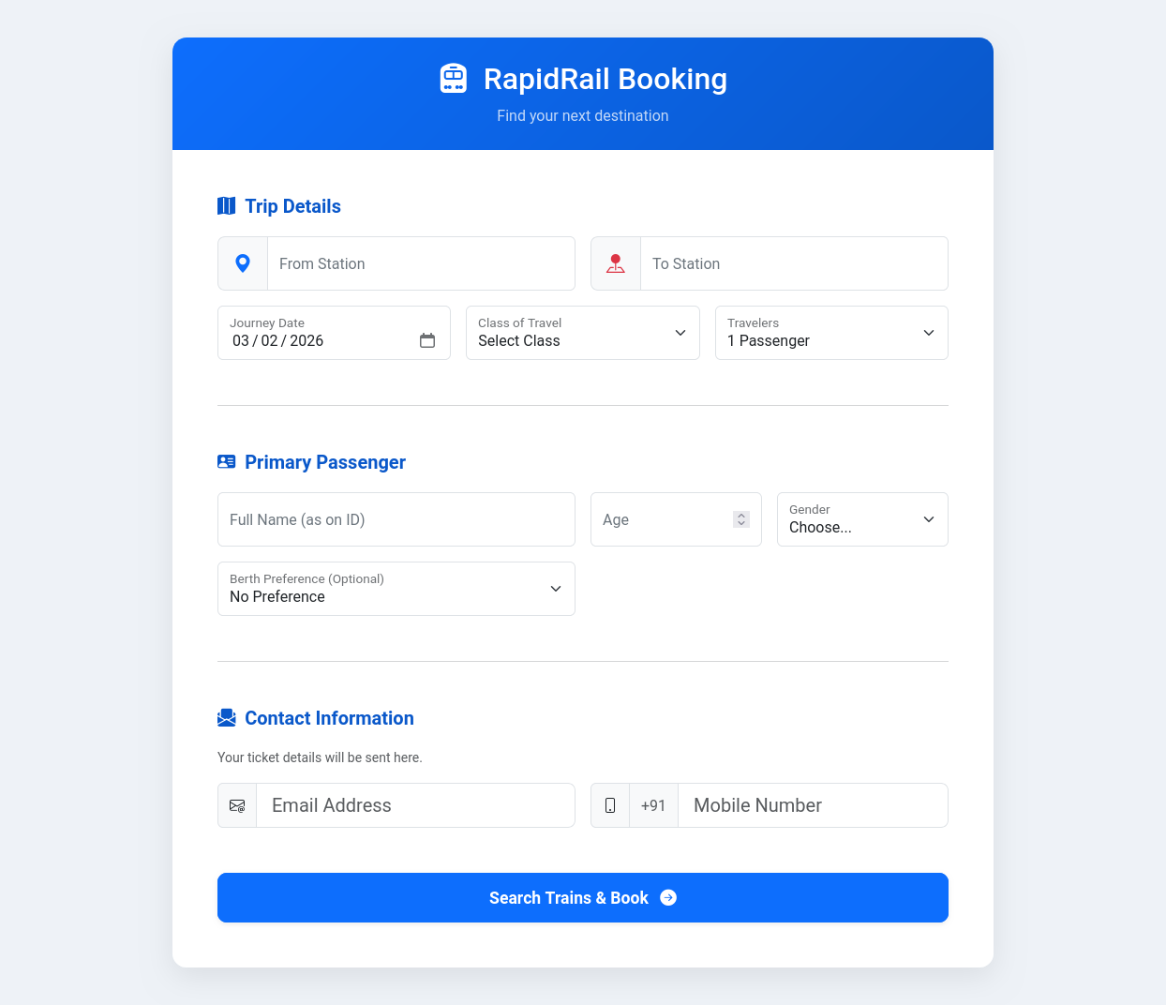
Q2.Design an attractive ‘magazine cover page’ using different bootstrap elements.
<!DOCTYPE html>
<html lang="en">
<head>
<meta charset="UTF-8">
<meta name="viewport" content="width=device-width, initial-scale=1.0">
<title>Magazine Cover Design</title>
<link href="https://cdn.jsdelivr.net/npm/bootstrap@5.3.0/dist/css/bootstrap.min.css" rel="stylesheet">
<link href="https://fonts.googleapis.com/css2?family=Oswald:wght@700&family=Playfair+Display:ital,wght@1,700&family=Roboto:wght@300;400;700&display=swap" rel="stylesheet">
<style>
/* Custom CSS for Magazine aesthetics */
body, html {
height: 100%;
margin: 0;
font-family: 'Roboto', sans-serif;
}

/* The Main Container holding the background image */
.magazine-cover {
/* Use a striking high-quality image.
Replace this URL with your desired image if needed.
This is a futuristic placeholder from Unsplash. */
background-image: url('https://images.unsplash.com/photo-1535378620166-273708d44e4c?q=80&w=2657&auto=format&fit=crop');
background-size: cover;
background-position: center center;
background-repeat: no-repeat;
min-height: 100vh; /* Full viewport height */
position: relative;
/* Add a subtle dark overlay to ensure text readability everywhere */
box-shadow: inset 0 0 0 2000px rgba(0, 0, 0, 0.3);
}

/* Typography Styling */
.masthead {
font-family: 'Oswald', sans-serif;
font-size: 5rem; /* Massive title */
letter-spacing: 5px;
text-shadow: 2px 2px 10px rgba(0,0,0,0.7);
}

.cover-headline {
font-family: 'Oswald', sans-serif;
font-size: 4rem;
line-height: 1.1;
text-transform: uppercase;
text-shadow: 2px 2px 8px rgba(0,0,0,0.8);
}

.teaser-headline {
font-family: 'Oswald', sans-serif;
text-transform: uppercase;
font-weight: 700;
letter-spacing: 1px;
text-shadow: 1px 1px 5px rgba(0,0,0,0.6);
}

.lead-text {
font-family: 'Playfair Display', serif;
font-style: italic;
font-size: 1.5rem;
text-shadow: 1px 1px 3px rgba(0,0,0,0.8);
}

/* Utility to make text pop off busy backgrounds */
.text-shadow-pop {
text-shadow: 2px 2px 4px #000000;
}

/* Gradient overlays for specific sections to enhance readability */
.overlay-gradient-bottom {
background: linear-gradient(to top, rgba(0,0,0,0.9) 0%, rgba(0,0,0,0) 100%);
padding-top: 100px; /* Give space for the gradient to fade in */
}

/* Responsive adjustments */
@media (max-width: 768px) {
.masthead { font-size: 3.5rem; }
.cover-headline { font-size: 2.5rem; }
}
</style>
</head>
<body>

<div class="container-fluid magazine-cover d-flex flex-column justify-content-between p-0">

<header class="text-center pt-4 pb-2">
<h1 class="masthead text-white fw-bold mb-0">INNOVATE</h1>
<div class="text-white-50 d-flex justify-content-center gap-3 fw-light text-uppercase small ls-2">
<span>Issue 42</span> | <span>Future Tech Edition</span> | <span>$12.99 US</span>
</div>
</header>

<div class="row flex-grow-1 align-items-center m-0 px-4">

<div class="col-md-3 d-none d-md-block text-white text-start">
<div class="mb-5">
<span class="badge bg-warning text-dark mb-2 rounded-0">MUST READ</span>
<h4 class="teaser-headline text-white">The Neural Link Dilemma</h4>
<p class="small opacity-75">Are we moving too fast?</p>
</div>

<div class="mb-5">
<h4 class="teaser-headline text-info">Quantum Leap</h4>
<p class="small opacity-75">Google's new 1M Qubit chip explained.</p>
<a href="#" class="link-light text-decoration-none small text-uppercase fw-bold border-bottom border-info">Read More &rarr;</a>
</div>
</div>

<div class="col-md-6"></div>

<div class="col-md-3 d-none d-md-block text-white text-end">
<div class="mb-5">
<h5 class="text-uppercase fw-bold text-danger ls-1 mb-1">Profile</h5>
<h4 class="teaser-headline">Elon's Mars City Plans</h4>
</div>
<div class="mb-5">
<div class="border-end border-3 border-success pe-3">
<h5 class="text-uppercase text-success fw-bold mb-0">Sustainability</h5>
<h4 class="teaser-headline mb-0">Vertical Farming</h4>
<p class="small opacity-75">Feeding 10 Billion</p>
</div>
</div>
</div>
</div>

<footer class="overlay-gradient-bottom px-4 px-md-5 pb-5 text-white">
<div class="row">
<div class="col-lg-8 text-start">
<h2 class="cover-headline fw-bold mb-2">THE CYBORG <span class="text-warning">REVOLUTION</span></h2>

<p class="lead-text text-white mb-4 w-75">
Merging man and machine is no longer science fiction. It's happening now.
</p>

<div class="d-flex align-items-center">
<span class="badge bg-danger fs-6 rounded-pill me-3 px-3 py-2">EXCLUSIVE REPORT</span>
<span class="text-uppercase small ls-2 fw-bold opacity-75">Page 45</span>
</div>
</div>

<div class="col-lg-4 d-none d-lg-flex align-items-end justify-content-end">
<div class="text-end opacity-50">
<i class="bi bi-upc-scan" style="font-size: 4rem;"></i>
<p class="small mb-0 ls-2">ISSN 1002-495X</p>
</div>
</div>
</div>
</footer>

</div>

<script src="https://cdn.jsdelivr.net/npm/bootstrap@5.3.0/dist/js/bootstrap.bundle.min.js"></script>
<link rel="stylesheet" href="https://cdn.jsdelivr.net/npm/bootstrap-icons@1.10.5/font/bootstrap-icons.css">
</body>
</html>
